Vaya Manufacturing Tool Development Setup

# Software Environment Description.

This tool is developed using Python 2.7.3 and PyQt4. To compile this project, you need to setup the environment as below:

## 1. Install Python 2.7.x for Windows

Download Python 2.7.x version for Windows and install into your computer.

<https://www.python.org/downloads/>

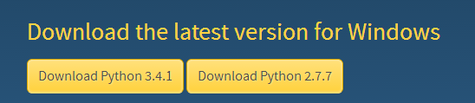

## 2. Install Python 2.7.x Excel package. This Library is used for generate the test report.

<http://www.python-excel.org/>

## 3. Install the Python Install. This tool is for generating a executable file for the computer which hasn’t install Python environment.

<http://www.pyinstaller.org/>

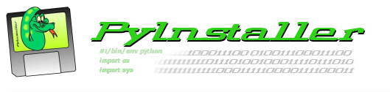

## 4. Install the Python Serial Port Library to access the Serial Port

<http://pyserial.sourceforge.net/>

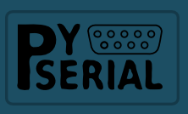

## 5. Install the PyQt for Python 2.7.x from Riverbank.

<http://www.riverbankcomputing.co.uk/software/pyqt/download>



## 6. Install the Eric4 IDE.

<http://eric-ide.python-projects.org/>

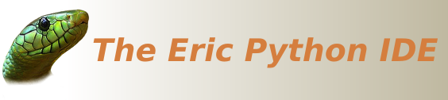

After install all the tools above, you have basically setup the Python 2.7.x GUI design environment for Qt4.